Sugarcane Production Analysis Using Python

1. Project Overview
Sugarcane is one of the most important cash crops in the world and is widely used for sugar production. Different countries produce sugarcane in different quantities depending on climate conditions, cultivated area, and agricultural practices.
The purpose of this project is to analyze global sugarcane production data using Python. Through Exploratory Data Analysis (EDA), different patterns and relationships were identified among production, acreage, yield, and continent-wise contributions.

2. Dataset Summary
The dataset contains information related to sugarcane production from different countries across the world.
Features Used
- Country
- Continent
- Production (Tons)
- Acreage (Hectare)
- Yield (Kg/Hectare)
- Production per Person (Kg)
The dataset was used to compare sugarcane production among countries and continents and to understand factors affecting production.

3. Exploratory Data Analysis Using Python
Production Distribution by Continent
The pie chart shows the percentage contribution of each continent in total sugarcane production.
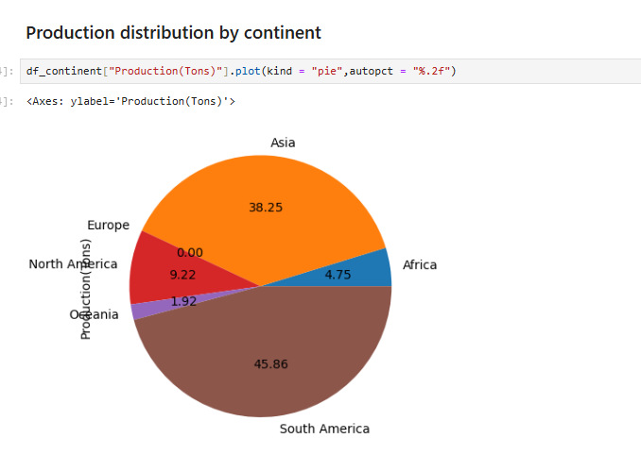
It can be observed that South America contributes the largest share of global sugarcane production. Asia is the second largest contributor, while Europe contributes very little.

Number of Sugarcane Producing Countries by Continent
The graph shows the number of countries involved in sugarcane production in each continent.
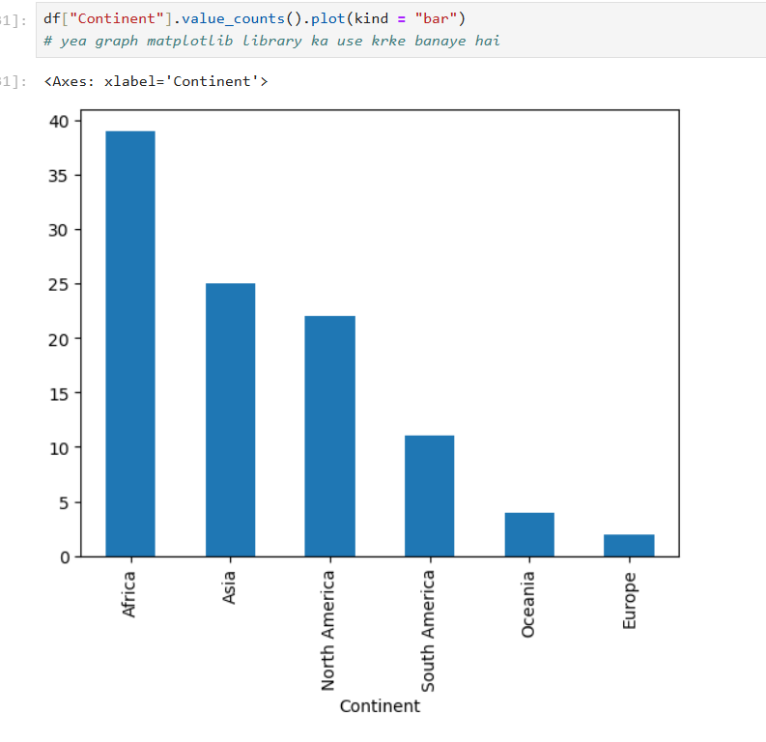
Africa has the highest number of sugarcane-producing countries. Europe has the lowest number of producing countries among all continents.

Sugarcane Production by Continent
The bar chart compares total sugarcane production among continents.
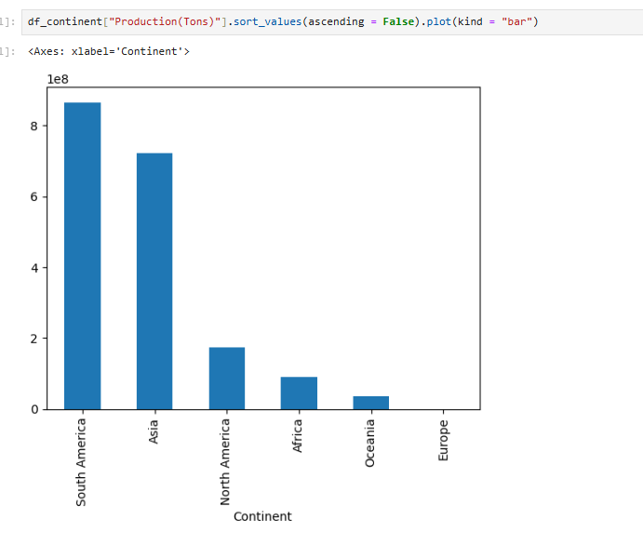
South America records the highest production, followed by Asia. Europe has the lowest production level.

Acreage Distribution by Continent
This graph compares the total cultivated area under sugarcane among continents.
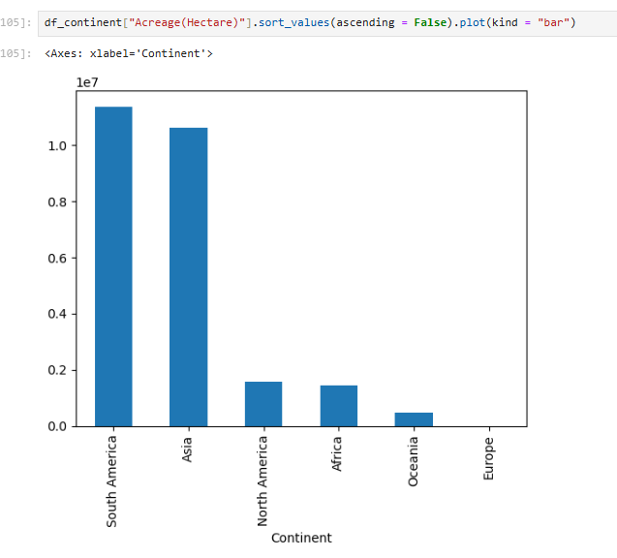
South America and Asia have the largest acreage under sugarcane cultivation. Europe has the smallest cultivated area.

Production Based on Number of Countries
The line graph compares production with the number of producing countries.
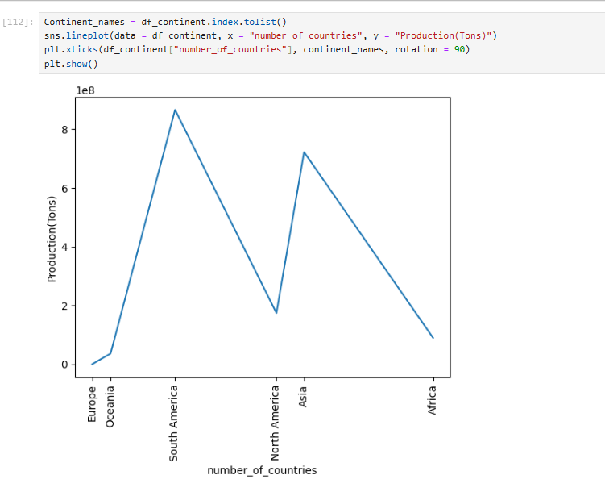
The graph indicates that a higher number of countries does not necessarily mean higher production. South America has fewer countries but much higher production.

Relationship Between Yield and Production
A scatter plot was used to study the relationship between yield and production.
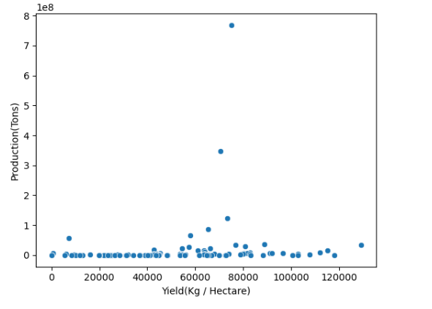
The graph shows that countries with high yield do not always have the highest production. Production also depends on the area under cultivation.

Relationship Between Acreage and Production
The scatter plot compares acreage and production.
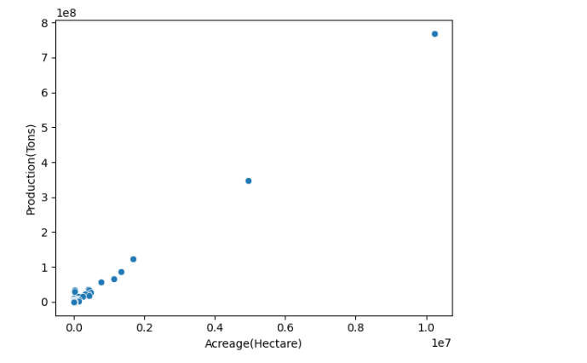
A positive relationship can be observed between acreage and production. Countries with larger cultivated areas generally produce more sugarcane.

Top 10 Countries by Yield
The following graph shows the countries with the highest sugarcane yield.
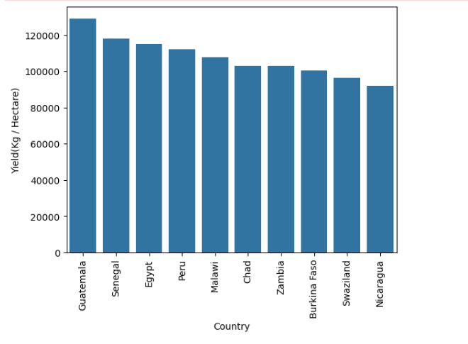
Guatemala has the highest yield among the countries in the dataset. Senegal and Egypt also show high productivity.

Top 10 Countries by Acreage
The graph shows countries having the largest cultivated area under sugarcane.
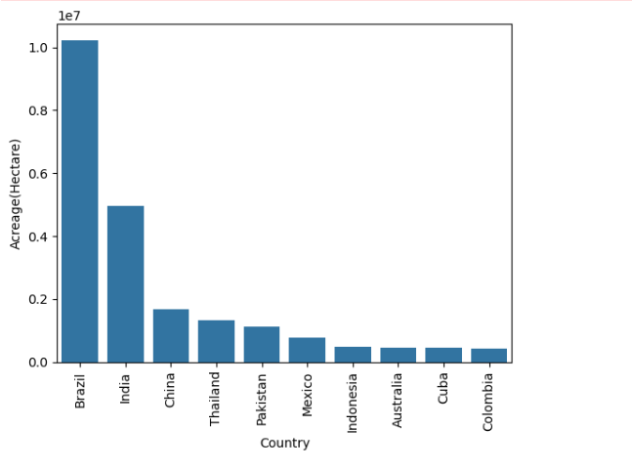
Brazil ranks first in acreage, followed by India and China.

Top 10 Sugarcane Producing Countries
This graph compares the production of the top sugarcane-producing countries.
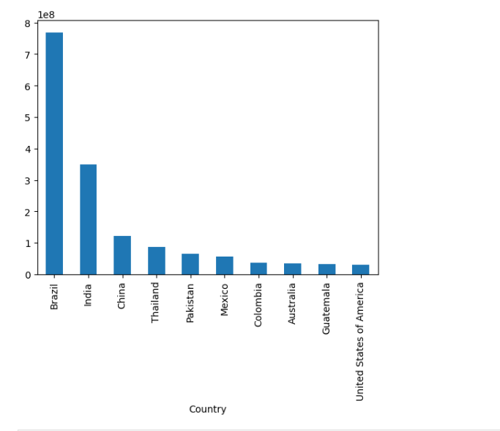
Brazil is the largest sugarcane producer in the world. India ranks second, while China and Thailand also contribute significantly.

Country-wise Production Distribution
The graph shows the distribution of sugarcane production among countries.
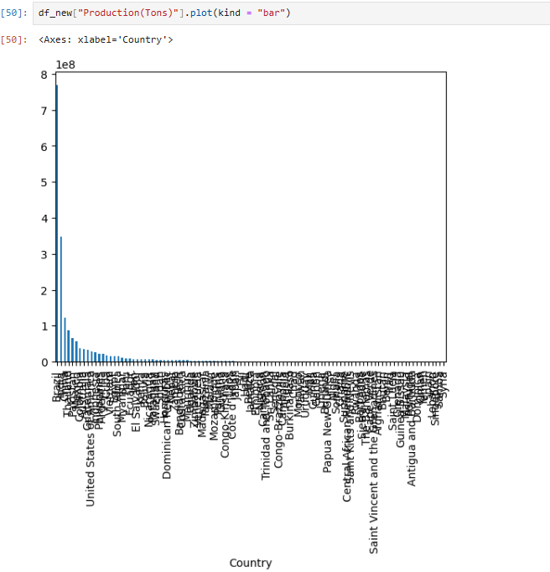
A small number of countries contribute a large share of global sugarcane production. Brazil alone contributes a significant percentage of total production.

Distribution Analysis
Histograms were used to understand the distribution of production, acreage, yield, and production per person.
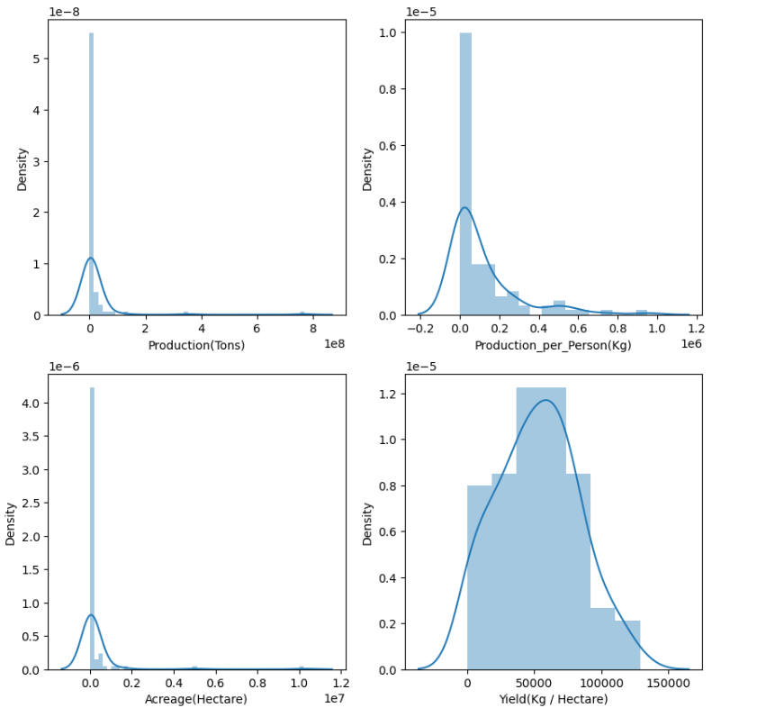
The analysis shows that production and acreage are highly skewed because a few countries have very high values compared to the rest. Yield distribution is comparatively more balanced.

Box Plot Analysis
Box plots were created to identify outliers in the dataset.
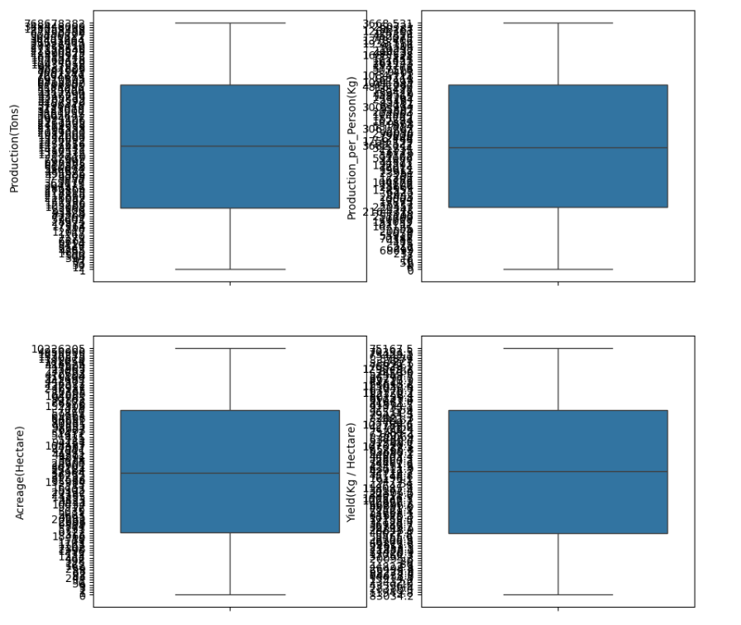
The plots indicate the presence of outliers in production and acreage. Some countries have exceptionally high values compared to the majority of countries.

4. Key Findings
- Brazil is the largest sugarcane producer in the dataset.
- India is the second-largest producer.
- South America contributes the highest share of global production.
- Africa has the highest number of sugarcane-producing countries.
- Guatemala records the highest yield per hectare.
- Acreage has a strong impact on total production.
- A few countries contribute a major portion of global sugarcane production.

5. Conclusion
In this project, sugarcane production data from different countries was analyzed using Python. Various visualizations helped in understanding production patterns, continent-wise contributions, acreage distribution, and yield performance.
The analysis showed that Brazil dominates global sugarcane production, while South America contributes the highest share among all continents. The study also revealed that acreage plays an important role in determining total production. Overall, this project helped in understanding real-world agricultural data through data analysis and visualization techniques.

